Streamtlit for chatbot applications:
1. st.chat_message() : A container used to display messages in a chat interface with roles like user or assistant.
- with st.chat_message('user'):
- st.text('Hi')

- with st.chat_message('assistant'):
- st.text('How can I help you?')
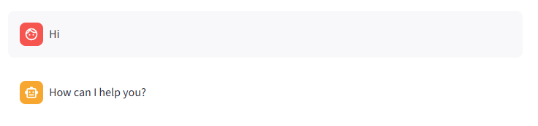
2. st.chat_input() : A widget that captures the user’s message from a chat-style input box and returns it when submitted.
user_input=st.chat_input('Type here')
3. st.session_state : A persistent dictionary that stores data across reruns, used to maintain chat history and app state.
if 'message_history' not in st.session_state:
st.session_state['message_history'] =[]

for message in st.session_state['message_history']:
with st.chat_message(message['role']):
st.text(message['content'])
#------------------------------
st.session_state['message_history'].append({'role':'user','content':user_input})

4.st.write_stream: Streams and displays data (like LLM responses) incrementally in real time in a type writer fashion as it is generated.
ai_message = st.write_stream(
message_chunk.content for message_chunk,metadata in chatbot.stream(
{'messages': [HumanMessage(contenet='What is the recipe to make pasta')]},
config=config,stream_mode='messages'
)
)

5.st.sidebar.title() : Displays a main title at the top of the sidebar.
6. st.sidebar.button() : Creates a clickable button in the sidebar that can trigger an action when pressed. If button is clicked particular function is called.
if st.sidebar.button('New Chat'):
reset_chat()

7.st.sidebar.header() : Displays a section header in the sidebar to organize content below it.
8. st.sidebar.text() → Displays plain, unformatted static text in the sidebar.
# ------------------ Sidebar UI ------------------------------
st.sidebar.title('LangGraph Chatbot')
st.sidebar.button('New Chat')
st.sidebar.header('My Conversations')
st.sidebar.text(st.session_state['thread_id'])
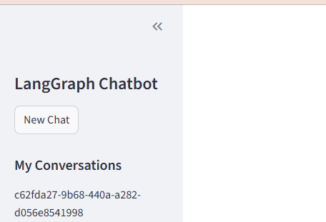
9. st.markdown()
10.st.text()

